A guide to creating a GitHub repository 

Create an account

The first thing you need to do is set up a free user account. Simply visit [https://github.com](https://github.com/), choose a user name that isn’t already taken, provide an email address and a password, and click the big green “Sign up for GitHub” button. Git Hub will send you an email to confirm your email address.

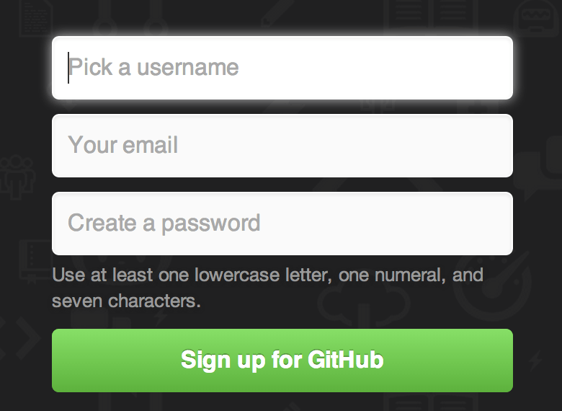

Sign in

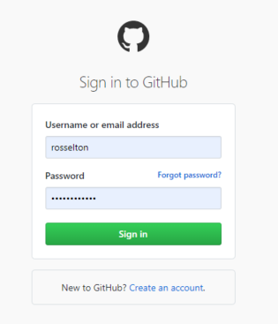

Clicking the Octocat logo at the top-left of the screen will take you to your dashboard page. You’re now ready to use GitHub.

Create a repository

To make a new repository, click either the green ‘New’ button top-left of the dashboard page, or the plus button top right of the page near your profile picture to bring down a menu.

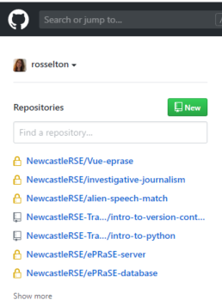 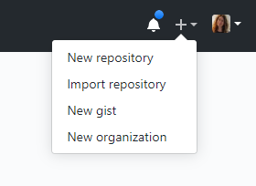

You will then be able to create a new repository by filling in a form similar to the one below. Create a suitable name for your repository. A green tick will shown if this name is available to use. Select a public or private setting.The click the green ‘Create repository’ button at the bottom.

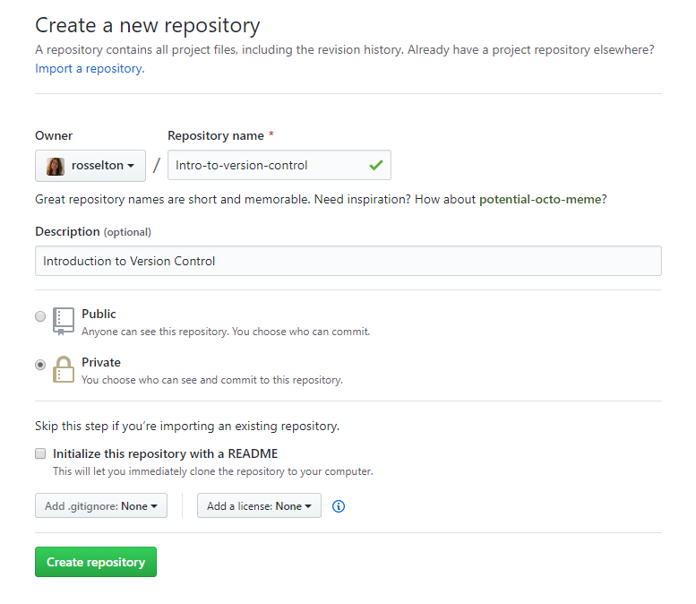

Adding files to your repository

Since we have already created a repository locally, we are interested in the second section of instructions. **‘..or push an existing repository form the command line**’.

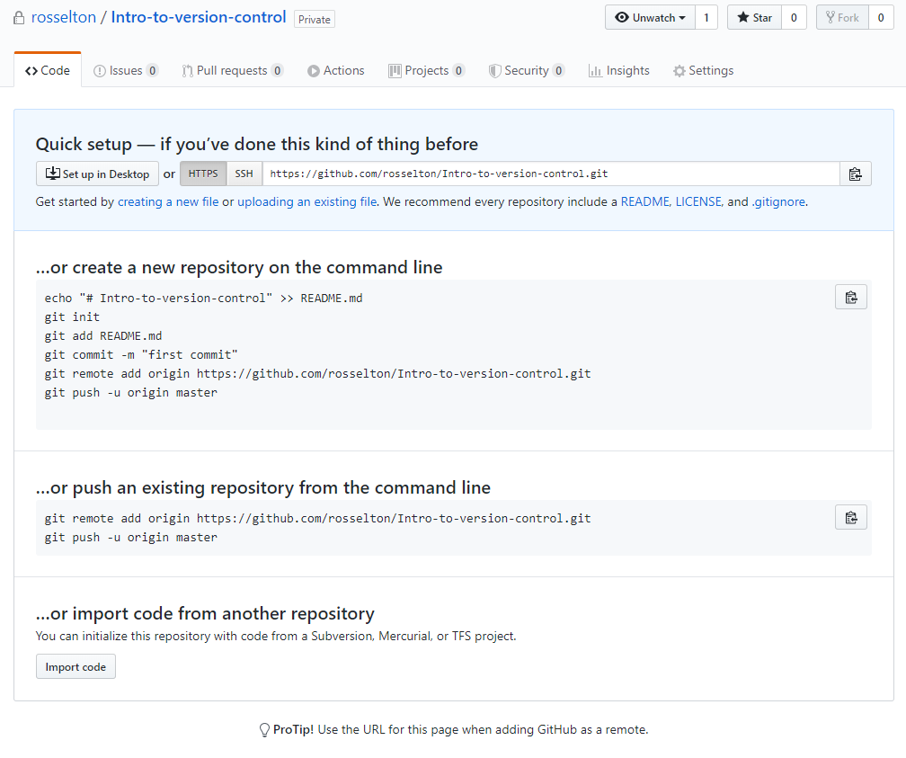

You can copy the code directly from the page, or just type it in at the Git Shell. The shell will run through the commands and this will become linked to your local code repository.